***RenderMan and OpenGL Shaders***

CS557

Project # 5

Chao Zhang

1. Source listings

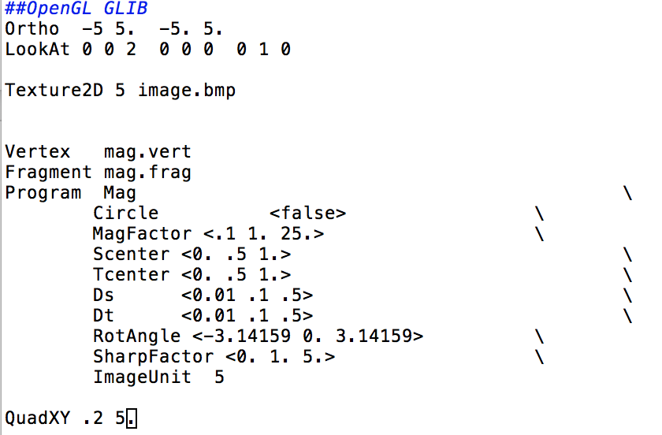

mag.glib

This is the glib file. This file includes all the basic information about this project. The shader type which is vertex shader and the fragment shader. The circle’s default is false, so the Magic Lens is a rectangle. If change the circle to true, the Magic Lens will be a circle. The Ds and Dt will change the size of the Lens. The Scenter and Tcenter changes the position of the Lens. MagFactor, Rotangle and sharpFactor will change the magnified, rotated, and sharpened.

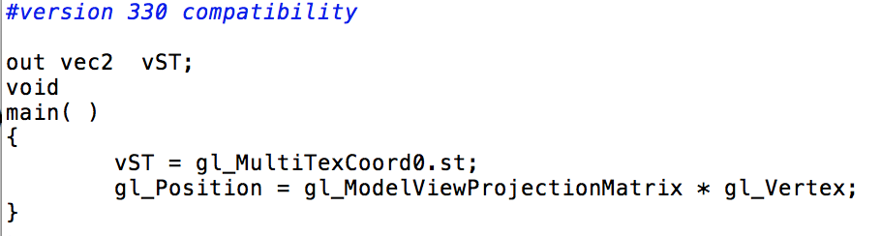

mag.vert

This project almost have nothing to do with the vertex sharder. Just the basic coordinate information.

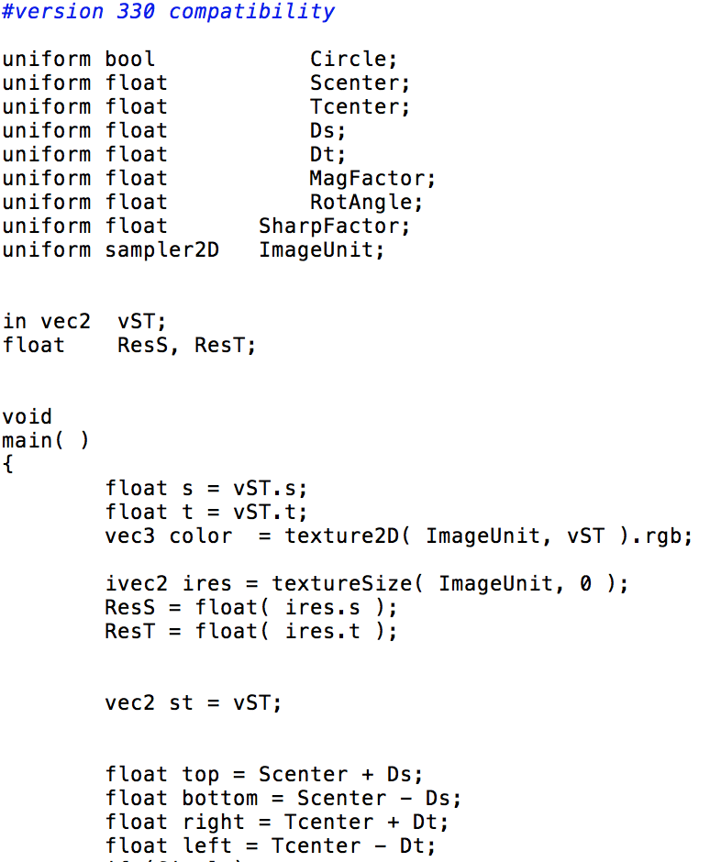

part 1 mag.frag

This is the first part of the fragment shader.

ivec2 ires = textureSize( ImageUnit, 0 );

ResS = float( ires.s );

ResT = float( ires.t ); Those lines treat the image as a texture. The lines under that gives the range of the lens.

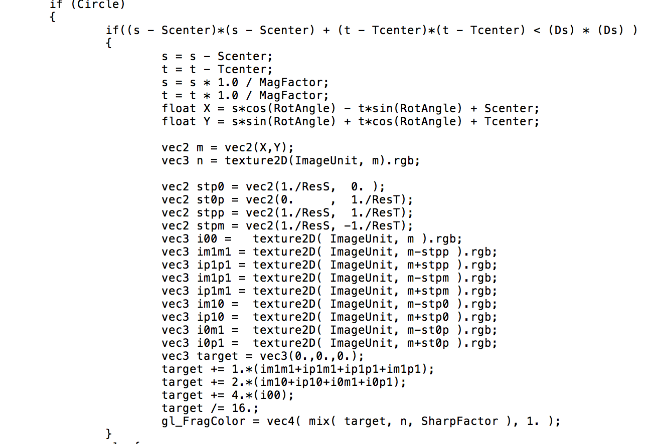

part 2 mag.frag

This is the part 2 of the fragment shader. This part is for the circle lens. I use the formula to find if it is inside the circle lens or not. If inside the lens,

s = s - Scenter;

t = t - Tcenter;

s = s * 1.0 / MagFactor;

t = t * 1.0 / MagFactor; this can do the magnify on the inside part. It use the old length multiple the 1/MagFactor to get the new length.

float X = s*cos(RotAngle) - t*sin(RotAngle) + Scenter;

float Y = s*sin(RotAngle) + t*cos(RotAngle) + Tcenter;

Those are the rotation formula. The reason why it need to plus the Scenter or Tcenter is the inside part need to rotation around the center. The sharpening function is come from the class formula. Because it is on the vertex after no matter rotation or magnify, so I create the m as the new position. For the vertex outside the lens, it didn’t change.

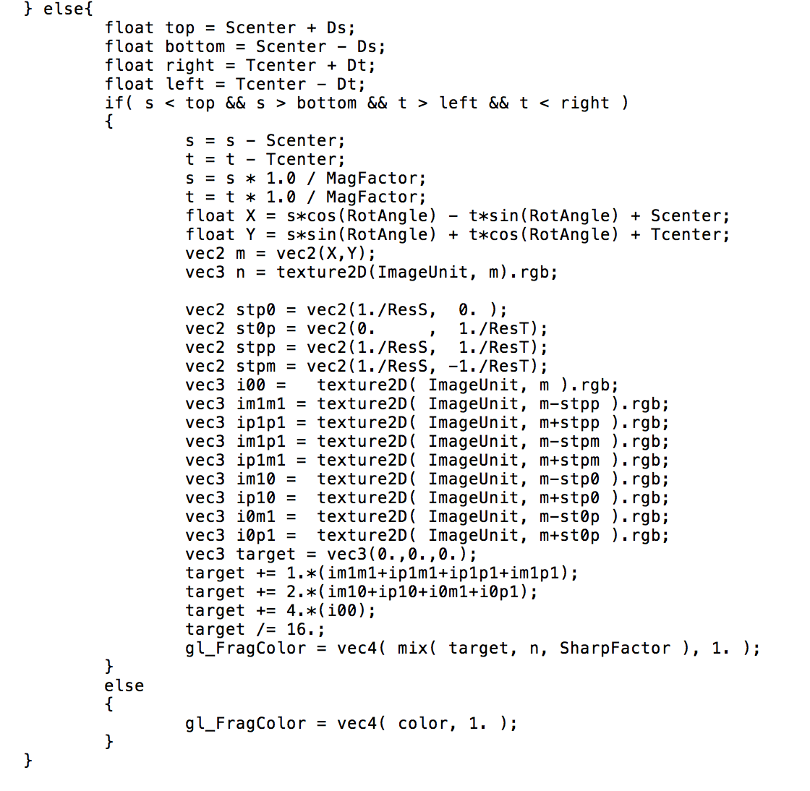

part 3 mag.frag

This part is the same as the part 2, the only different is the lens is a rectangle. So I use the different formula to check if it is inside the lens or not.

1. Result

